How to change the extender' WIFI name & password

1. Connect your laptop or mobile phone to the extender, via an Ethernet cable, or via wireless.
2. Launch a web browser, type plc.tendawifi.com in the address bar of the browser, and tap Enter on the keyboard.

3. There are 11 languages (English, Deutsch, Español, Français, Italiano, Polski, Română, Magyar, Português, Türkçe and Pусский) of the User Interface. And it will match with the browser’s language automatically. You can also select a language manually.
The login page will appear. Type the default login password admin, and click Login.

1.In the wireless settings part, you can configure the WiFi name and password manually, and specify the time that you want to enable/disable your WiFi.( The password length can be set from 8 to 63 bits)
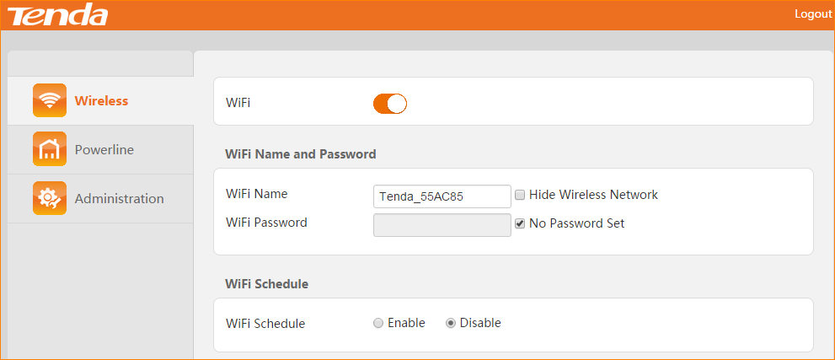
2. Click OK on the bottom of this page to apply your settings.

